The expressive use of possessives in three Venezuelandialects. *

The expressive use of possessives in three Venezuelan dialects.

DOI: 10.32870/sincronia.axxv.n79.32a21

Krístel Guirado
Central University of Venezuela/University of Zaragoza (VENEZUELA)
CE: kristelguirado@gmail.com / ORCID ID: 0000-0002-7933-2758

This work is licensed under a Creative Commons Attribution-NonCoercial 4.0 International License

Received: 25/09/2020

Reviewed: 18/10/2020
Accepted: 06/11/2020

SUMMARY

In this research, I analyze five uses of the possessive of 1st sg., typical of the Spanish spoken in Venezuela:alternation in nominal context(mi casa ~ la casa mía), in adverbial context (infront of me ~ mine), in verbal context (mocks me~mine, a house made mine ~ by me), redundant possessive (my house of mine)and ponderative (heboughtmy house). I studythe cases in the dialects of three cities (Caracas, Maracaibo, Mérida) and present the research in two parts; in the first, I statistically analyze the possessive in nominal context (mixed effects and trees of conditional inference) to determine if the forms are conditioned by linguistic and social factors; in the second, I describe the other cases – less abundant in the sample – to specify their occurrence and establish the expressive character of their use. pragmatic. The results show that: i. the semantic relationships of social coexistence and self-realization, the attribute function and the adult speakers of low level favor the use of the tonic postnominal possessive; ii. in contrast, emphatic possessives (post-adverbial, appreciative, ponderative and redundant,) are more common in young Caracas and their use turns out to be an effective strategy to give expressive enhancement to the statement.

Keywords: Possessive of 1st sg. Dialect variation. Mixed effects model. Trees of conditional inference. Intensification. Expressive enhancement.

ABSTRACT

In this research, I analyze five use of the first-person singular possessive, typical of Spanish spoken in Venezuela: alternation in nominal context (mi casa ~ la casa mía),alternation in adverbial context (in front of me ~ mine),alternation in verbal context (mocks me~mine, a house made mine ~ by me),redundantpossessive (my house of mine) and ponderative possessive (hebought me my house). I study the cases in the dialects of three cities (Caracas, Maracaibo, Mérida) and I present the results in two parts; in the first, I statistically analyze the possessive in nominal context (mixed effects and conditional trees) to determine if the forms are conditioned by linguistic and social factors; in the second, I describe the other cases –less abundant in the sample– to specify their occurrence and establish the expressive character of their pragmatic use. The results show that: i. the semantic relationships of social coexistence and self-realization, the attribute function, and low-level adult speakers favor the use of the postnominal stressed forms; ii. in contrast, emphatic possessives (post-adverbial, appreciative, ponderative, and redundant) are more common in young Caracas speakers and their use constitutes an effective strategy to give expressive enhancement to the statement.

Keywords: First-person singular possessive. Dialectal variation. Mixed effects model. Conditional inference trees. Intensification. Expressive enhancement.

1. Introduction: the expression of possession in Spanish
In Spanish, the notion of 'possession' can be expressed with the use of a determinative adjective atone anteposed(mi - su - nuestra ... house),of a postponed tonic(the house mine - yours - ours), or with a periphastic construction known as analytical possessive (Rosa's house - my mom's). The pre-emptor and the analytical are the most frequent uses, while the postponed is reserved to mark emphasis and contrast (Picallo & Rigau, 1999; Real Academia Española & Asociación de Academias de la Lengua Española, ss. RAE & ASALE, 2009).
Picallo and Rigau (1999, §15.2.4) also warn that some jobs of the anteposition are used "to intensify or alter a characteristic that is assumed to be supposed or inherent." Intensification can ratify the characteristic(I had my coffee and my daily toast),point out its unexpected character (Theseornaments have their grace)or reinforce an attribute (Thisinstitution already has its two centuries of existence).
Another use differentiated by the grammatical tradition is the so-called doubled or duplicated, double or redundant possessive, constructions that "repeat the information corresponding to the possessor within the nominal group" (RAE & ASALE, 2009, §18.4f). Two variants are distinguished, with possessive atone before the analytical(my house of me)and with postponed tonic (my house of mine). The New Grammar of the Spanish Language (ss. NGLE) describes these constructions as "improper of general Spanish", although they are not alien to the development of the language, as they are documented in medieval and classical Castilian. Its current use is frequent in some Andean and Central American regions; and in European Spanish, it is restricted to the second person of courtesy in popular speech.
Regarding the use of the possessive with locative adverbs, the NGLE reports three guidelines: analytical(behind me),male postponed (behind me)and feminine (behind me),butexpresses its preference for the first, since the postponed lose prestige in less popular records. Although Picallo and Rigau (1999, §15.3.1) identify it as a proper use "of colloquial or dialectal speech in peninsular Spanish", "very common in American Spanish", its use is a cause for concern and normative opinions.
Consequently, the objective of this research is to study five phenomena associated with the use of the possessives of 1st sg., present in the Spanish spoken in Venezuela: i. alternation in nominal context: my house ~ the house mine; ii. alternation in adverbial context: in front of me ~ mine; iii. alternation in verbal context (appreciative): a house made mine ~ of/by me; iv. redundant emphatic use: my house mine; and, v. emphatic weight use: bought me my house.
The phenomena are analyzed in three cities (Caracas, Mérida and Maracaibo), located in different dialectal areas of the country (central, Andean and Zulian), to determine – when frequency permits – if the forms are linguistically, socially and/or dialectally conditioned and to establish the pragmatic nature of their use.
I have focused my attention on the study of the 1st person because it is the most frequent in speech (Silva-Corvalán & Enrique-Arias, 2017) and its paradigm presents a lower morphological and referential ambiguity: it only registers the prenominal form (my, my, without gender variation) and postnominal coupling (mine-o-s); the latter does not alternate with the prepositional group of + PRON (*the house of I/me); both designate a single possessor and have an unambiguous referent (the speaker), present in the discursive context, with greater animacity, concreteness and perspective. The implication of the individuality of the speaker contrasts the 1st sg. to the others of the paradigm. By virtue of the fact that the ultimate intention of this research is to point out that the marked uses are an expression of the subjectivity of the speaker, the 1st sg. is the maximum expression of this.

2. The use of the possessives of 1st sg. in the Spanish of Venezuela
2.1. General descriptions
Ledezma and Obregón (1990) warn that, in informal speech, the possessive postponed to the nominal group is more frequent than the apocopate forms. Ledezma and Barrera (1985), Ledezma and Obregón (1990) and Bentivoglio and Sedano (1992) also mention the postponed use of possessives with adverbs of place(behind me). Bentivoglio and Sedano (1998, p.127) associate this use with the affective character of the expression:
When a Caracas native talks about something that belongs to him, he can say my mom, my children, your cousin instead of saying my mom, my children and your cousin. It seems that the use of the possessive adjective after the noun serves for the speaker to express a more affective bond with the person to whom he refers, a bond that, of course, can also extend to beings or objects equally loved and appreciated, but not human, such as my dog, my parakeet, my cart.

As for the false preposition, Ledezma and Barrera (1990) record its use in informal speech(do notbother, my doñita; I put on my heels; I aliñé my rice). On the other hand, they consider that the redundant possessive is not habitual, although they document some cases(answers all my crew; I learned to paint on my own).
Finally, I have called appreciative the use of the possessive tonic to replace a complement of regime – fixed or optional – headed by the prepositions by: these paintings are painted mine~by me;this little house is made mine~byme (Ledezma & Barrera, 1985) and: you are in love with me~withme; he makes fun of me~me (Guirado, 2012).

2.2. Empirical studies
2.2.1. Possessive in nominal context
De Stefano and Chumaceiro (1992) analyze the posesives of 1st sg. in nominal groups in the city of Caracas. The most frequent use was the antepuesto. The postponed uses were associated with nouns denoting familiarity(son, boyfriend, friend,etc.) and predicative phrases (That's myson). The authors also found correlation with speakers between 30 and 45 years old, of low socioeconomic status. In the end, they point out that the postponed uses "also communicate affective contents and stylistic values" (p. 826).
De Stefano (1996), in addition, analyzes these possessives in the speech of Maracaibo. In this variety, the postponed use was also not abundant and was associated with men over 60 years of age, equally, of the lowest levels. The author warns that the use of nouns familiar with both possessives was similar, which would empirically disprove the relationship between postponement and this type of nouns.
Lo Ponte (2016) identifies and illustrates the postponed use of 1st sg. in the interview of a young man from a poor neighborhood of Caracas, with a low level of education, deprived of liberty in a Caracas prison: "And if they hire me 'pa- que mate a friend of mine, I go and tell my friend and I go with my friend and kill him." (p. 69).
2.2.2. Post-adverbial possessive
De Stefano and Chumaceiro (1992) review the postponement of the possessive to the adverb(below me, in front of me, next to me 'together'), but this was scarce in caracas orality. Navarro (2001) also studies the alternation in the speech of Valencia, and only documents two cases in speakers of low social stratum (Ifelt the old one on top of me; I have some cousins who live in front of me).) Murguey (2010, p.65), on the other hand, documents "abundant occurrences of full forms of postponed possessives" in a sample of various Venezuelan cities (Caracas, Mérida, Margarita and Porlamar).

2.2.3. Possessive before emphatic
Finally, Ugueto (2015) conducts a case study of the possessive atonos anteposed(mi-tu-su) when they modifyphrases that designate objects or physical or psychological qualities, in six interviews of the current speech of Caracas. A significant proportion of cases of 1st sg. (27%) correspond to "expressive possessives" (partof my French that I know I know by... for my readings; I pour my water and soap again). On the pragmatic motivation of the use (emphasis), the author points out: "a suprasegmental phonic difference can be perceived auditorily between the pronunciation of the FNs in which the possessive expresses an emotive-expressive nuance" (p. 100).

3. Corpus and case selection
The exhibition consists of 144 recordings of the Dialectal Corpus for the sociolinguistic study of spanish spoken in Venezuela at the end of the twentieth century (Cf. Guirado, 2021). The CORDIA-VEN-sXX is a subcorpus, product of the reengineering of three corpora of the GREHV project (Cf. Bentivoglio, 1996), created with the purpose of making analysis in a microdiacrony of the twentieth century. The interviews are evenly distributed in three dialects: Maracaibo, Caracas and Mérida; four age groups: 14 to 29 years, 30 to 45, 46 to 60 and 61 years or older; three socio-economic levels: high, medium and low; and sex: men and women. Table 1 shows the distribution:
Table 1. CORDIA-VEN-sXX
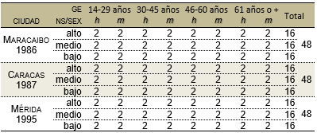
Source: (Guirado, 2021, p. 65)

I extracted from the corpus all the declarative clauses in which possessive forms of 1st sg.(mi-s, mi-o-s, of/byme)appear incontexts of nominal, adverbial and verbal modification. I eliminated from the analysis the pronominal uses (thosewords were/seem mine, my [children] are big)and the repetitions, hesitations and other corrections of the oral text.
Nor did I take into account the use of possessives in interjections(my God! ) and vocative (mylove, my life, mija, son of my soul, my son, my dear),nor their invariable use in sayings (I left my grain of sand), titles ("My primary book"), quotes from songs ("Kid I came out of my garden, lord that I have no door") and the emphatic use of the syntagma my person in place of the pronouns I, me, me (wearrived she and my person, remembers my person, attacked my person).
Finally, I reserved the particles that function as markers of point of view expression(in my way/wayof seeing, in my opinion, in my concept, in my opinion),and other lexicalized expressions (in my sight/reach 'in frontof me', in my face 'in front of me', on my own 'in my opinion, without counting others', in my life 'never/never', all my life 'always', [not] being alie/invention of mine -or, being my thing, for further study).

4. Analysis and discussion
The results of the research are presented and discussed in two parts. In the first (§4.1), a statistical analysis (distribution and inferential analysis) of the alternation of the possessive in nominal context is made. In the second (§4.2), the other uses are described, less frequent in the corpus(postadverbial, appreciative, redundant and ponderative).

4.1. Part One: Alternation of the possessive in nominal context
4.1.1. Variables studied and general distribution
The dependent variable of the study consists of two variants, the preposed form (1) and the postponed (2) of the possessive of 1st sg. to a nominal group:
(1) / Adjectival possessive of 1st sg. anteposed /
a. my skin is no longer for those needs (MB-B3FA)
b. my dad was a minister at that time (CA-A1MB)
c. I have my records... I bought ACDC discs (MD-A1MA)

(2) / Adjectival possessive of 1st sg. postponed /
a. my friends skated and... were glued from the grill (MB-B3MB)
b. My childhood was very beautiful (CA-C5MB)
c. my appointment is as a University Healer (MD-C5MA)

The total number of cases analyzed was 3663, of which the majority correspond to previous forms (92%, n: 3375). Table 2 shows the frequencies of use:
Table 2. Anteposition ~ postponement of the possessive of 1st sg. in the CORDIA-VEN-sXX
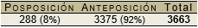
Source: Own elaboration

Below, the cases analyzed by dialect are broken down and compared with the frequencies recorded in four other American cities:

Table 3. Distribution of the postnominal possessive of 1st sg. in several American cities
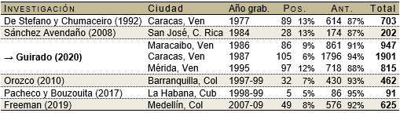
(Sánchez, 2008); (Orozco, 2210); (Pacheco and Bouzouita, 2017); (Freeman, 2019)
Source: Own elaboration

Table 3 shows that the aposed form is the most frequent in the speech of the seven cities. The highest trend of postnominal possessive is recorded in the Recordings of Caracas in 1977 (13%), San José de Costa Rica (13%) and Mérida (12%).
Since my interest is focused on describing the marked form of the possessive, I have tried to compensate for the insufficiency of the postnominal cases with a series of adjustments in the data. The first is to exclude interviews in which only one of the forms of the possessive is used, in order to reduce the disaggregation of data by speaker and ensure the greatest possible balance in contexts.
Consequently, the total number of speakers alternating both forms was restricted to 99 (49 women and 50 men), distributed relatively proportionally in the three cities (32 in Maracaibo, 33 in Caracas and 34 in Mérida) and the three levels (high: 30, medium: 30, low: 39). However, age groups have a partial proportionality, since young people are much less (young people: 17, adults: 29, full adults: 27, older adults: 26). When the sample was purified, the total occurrences were reduced to 2666. Subsequently, I designed a model of six independent variables, two linguistic: i. semantic relationship; and, ii. syntactic function; and four extralinguistic: i. age group; ii. socioeconomic status; iii. sex; and, iv. city.
4.1.2. The postnominal possessive and the semantic relationship
For the analysis of the semantic relationship variable denoted by the noun to which the possessive determines, I differentiated the entities into more or less human, and then categorized them according to more specific properties of the modified noun. Table 4 provides the percentages of use, calculated in the new distribution of cases:
Table 4. Percentage of postnominal possessive of 1st sg. with entities [+ HUM] and [– HUM]
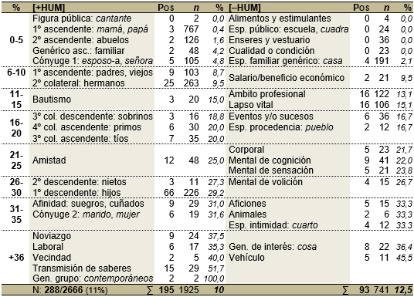
Source: Own elaboration.

On the one hand, the use of the possessive with more human entities [+HUM] allow to indicate favoritism by a public figure(singers);generic blood relations (ancestors,relatives), ascendant(mother, grandfather),collaterals of 2nd, 3rd and 4th grade (brothers, cousin, aunt, nephew)and descendants ( children, granddaughter); kinship by direct affinity(husband, wife)and indirect (mother-in-law, brother-in-law); as well as various social relationships (baptism, friendship, courtship, work, neighborliness and transmission of knowledge).
In Table 4, the links have been sorted ascending by percentage. According to the data, postponement is more frequent when establishing relationships of social proximity (+36%), marital affinity (spouse 32%, in-law relatives 31%), descending consanguinity (grandchildren 27%, children 29%) and friendship (25%); I exemplify these relationships in (3a-h):

(3) a. I think my generation is ... has undergone some changes (CA-C3MB)
b. I... I compare the... the schedules of my students right now (MB-B3FB)
c. my friend, this one who was my neighbor and I, went (CA-B1FA)
d. you have for example my driver, he lives in a small house (MB-D1FA)
e. my father-in-law looked a lot like ... to Gomez physically (MD-C3MB)
f. at home the voice is not raised more than my wife and I (MB-C5MB)
g. He has three children, mygranddaughter. Three Little Ones (CA-D5FA)
h. just like his father. The two sons of mine came out just like him (MB-B3FA)

As can be seen, the increase in postponed use is inversely associated with ascending blood ties, so that its use could be interpreted as an expressive resource to mark a greater degree of familiarity in those non-parental social relationships. Diagram 1 shows this correspondence:
Diagram 1. Postnominal possessive and expressive familiarity in entities [+HUM]
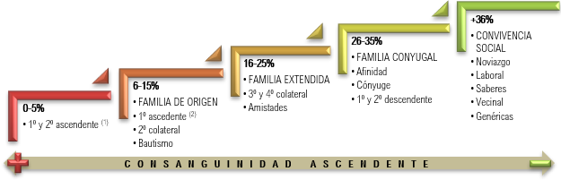
Source: Own elaboration

On the other hand, the possessive with non-human entities [-HUM] usually refers to belongings or physical and intellectual properties of the speaker. In this case, I grouped the nouns into animals(dog),food and stimulants (arepa, cigarette),belongings and clothing (bed, jacket),vehicles(car);spaces: public(school),family(house),origin(village),intimacy(fourth);economic benefit (scholarship). , salary), professionalfield (career, work), events andevents (birthdays, detention); vital lapse(epoch, childhood, life),corporal(hand, pulse); quality or condition(character, evil); mental processes: sensation(disenchantment),cognition and language (memories, opinion),volition (longing); hobbies(hobby)and generics of interest (thing, problem).
In Table 4, it is observed that the postponed use is favored by entities [-HUM] used to refer to possessions inherent to the private sphere -vehicle (45.5%), interests (36%), space of intimacy, pets and hobbies (33%)-, and to psychophysical processes of the speaker (21-30%); in (4) I offer some examples:
(4) a. then I took my car for a few laps around (MB-B3MA)
b. I fight with him because he takes... my things, take them away (MB-C1MA)
c. this is my room, she slept here and here I sleep, now (MD-B5MB)
d. dogs cherry to fight, knock down mine dog on one side (CA-B5MB)
and. I took ground floor because the... the... my life is the bushes (MB-B3FA)
f. is more my will than the dancers (MD-A3MB)
g. Mathematics, which was the... the... my annoyance, I didn't like them (MD-B1FA)
h. that... it's my thought, and I've always told you (MD-B5MB)
i. and they liked my voice and started [?]: "Hey, how well you sing!" (CA-A3MA)

With entities [–HUM], the use of the postponed also shows a continuum that goes from public to private life (cf. diagram 2) and its use results in a reinforcement of proximity in those concrete entities of exclusive usufruct of the speaker or abstract referring to his intimate introspection (common good vs. individual utility):

Diagram 2. Postnominal possessive and expression of proximity in entities [–HUM]
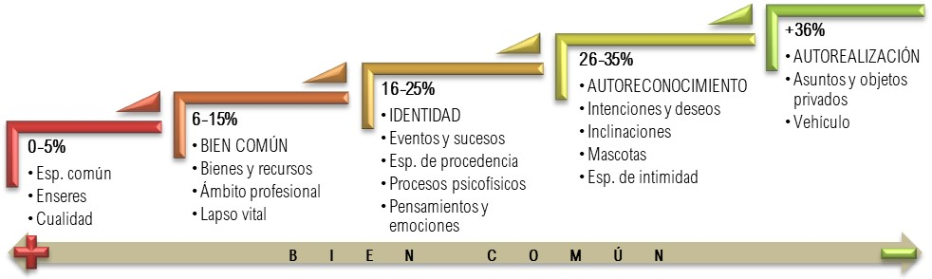
Source: Own elaboration

Table 4 also shows that some variants have zero or too low postponement frequencies compared to the anteposition. In this regard, I have followed the actions suggested by Guy (1988): identify and exclude invariable contexts and minimize the number of explanatory factors. For this reason, in a second adjustment of the data, I have excluded the cases that show a percentage of use less than 5% and regrouped the remaining categories according to the familiarity expressed in the relationships within the same range of percentages. Redistribution is provided in Table 5:
Table 5. Postnominal Possessive: Redistribution of the Semantic Relation Variable
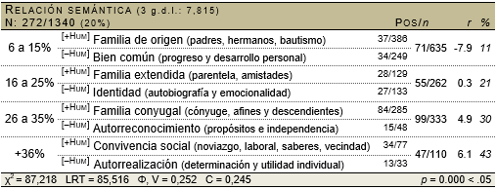
Source: Own elaboration

The analysis indicates a significant association between the position of the possessive and the semantic variable(p < .05). The results coincide with those already described: the tendency to postpone seems to increase with nouns that express social coexistence and self-realization(r= 6.1) and with entities that refer to the relationships derived from the conjugal nucleus and the self-recognition of the speaker (r= 4.9).

4.1.3. Postnominal possessive and syntactic function
For the analysis of the syntactic function of the nominal group, I classified the cases into: i. subject; ii. direct and indirect complement; iii. other verbal and nucleus complements; iv. attribute; v. subparagraphs and topicalizations. Table 6 shows the results:
Table 6. Distribution of the postnominal possessive of 1st sg. according to syntactic function
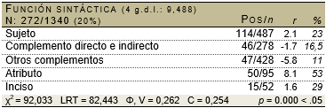
Source: Own elaboration

The attribute records the highest trend of postponement (53%) and the data indicate a notable association of dependence of the postponed possessive when modifying nominal groups in this function(r= 8.1). Likewise, it is observed that the subject function (r= 2.1) and the subparagraphs and topicalizations (r= 1.6) also contribute to the use:
(5) a. And well they can be friends of mine _{ATR} (CA-B5FA)
b. My first husband _{SUJ} lived there all his life (MB-B3FB)
c. smaller than this boy who came here, my grandson _{INC} (MD-D5FB)

4.1.4. The postnominal possessive and extralinguistic variables
Table 7 shows the postponed data according to each of the extralinguistic variables:

Table 7. Distribution of the postnominal possessive according to extralinguistic variables
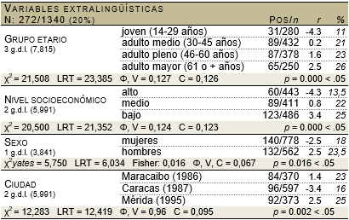
Source: Own elaboration

According to the results, older adults, men and natives of Mérida (r= 2.5) show some inclination towards the postponed form; this trend increases at the low level (r= 3.4). In Diagram 3, the percentages of each variant by variable are compared:
Diagram 3. Percentage of ante/postnominal possessive in extralinguistic variables
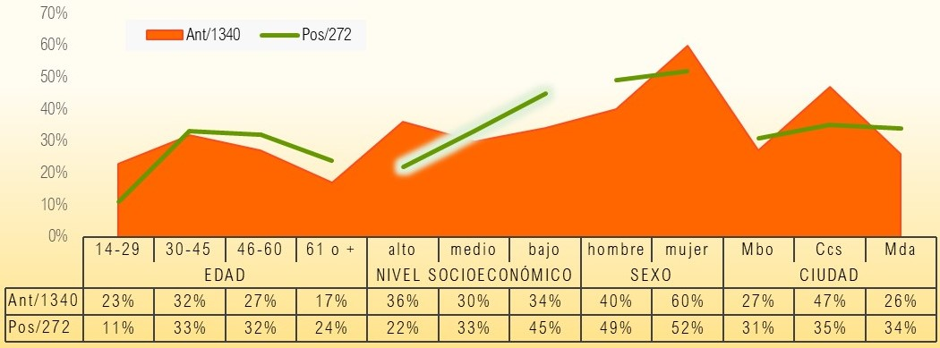
Source: Own elaboration

In diagram 3, the postponement line rises out of the anteposition area in variants whose residue is positive. Socioeconomic status is precisely the only factor that has an inverse pattern of distribution of proportions. Also, although the city draws a similar curve in both uses, the postponement rises in merideños and maracuchos, in contrast to the capital's speakers.

4.1.5. The postnominal possessive: inferential analysis
I used a binomial logistic regression analysis(up&down)to establish the joint contribution of the variables to the postponement. I processed the data with Rbrul (Johnson, 2009), a statistical program that can apply both the traditional fixed-effect model and a generalized linear mixed-effect model.
The fixed-effect model presupposes that the data of the predictors are indeed independent, a principle that makes it impossible to determine whether the frequency of a factor is random or the product of an individual variation. The mixed-effects model, on the other hand, includes random effects that allow this variation to be considered without distorting the coefficients of the fixed factors. Next, a first mixed-effects model is tested with the speaker as a random effect, which includes the six proposed variables:
Table 8. Joint contribution of variables to the POS_POS_ 1stsg. – Model 1
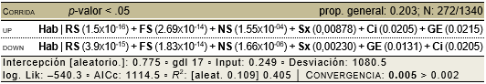
Source: Own elaboration

Table 8 shows the arrangement of the variables according to the different probability indices. Although all the variables are considered significant, in the adjustment of the model it is noted that the convergence of the data fails (0.005 > 0.002). Barr, Levy, Scheepers and Tily (2013, p.261) explain that the model can become unidentifiable when there is insufficient data to estimate the effects. When comparing the p-values, it is observed that the position of the age group variable differs in both runs. In this way, the reduction of combinatorial possibilities may originate in the lower proportion of cases in young speakers (cf. §4.1.1., supra). I have used Language, Variation Suite (Scrivner & Díaz-Campos, 2016) to obtain a conditional inference tree (AIC) of extralinguistic predictors to help me verify this hypothesis:
Diagram 4. Conditional inference tree with extralinguistic variables
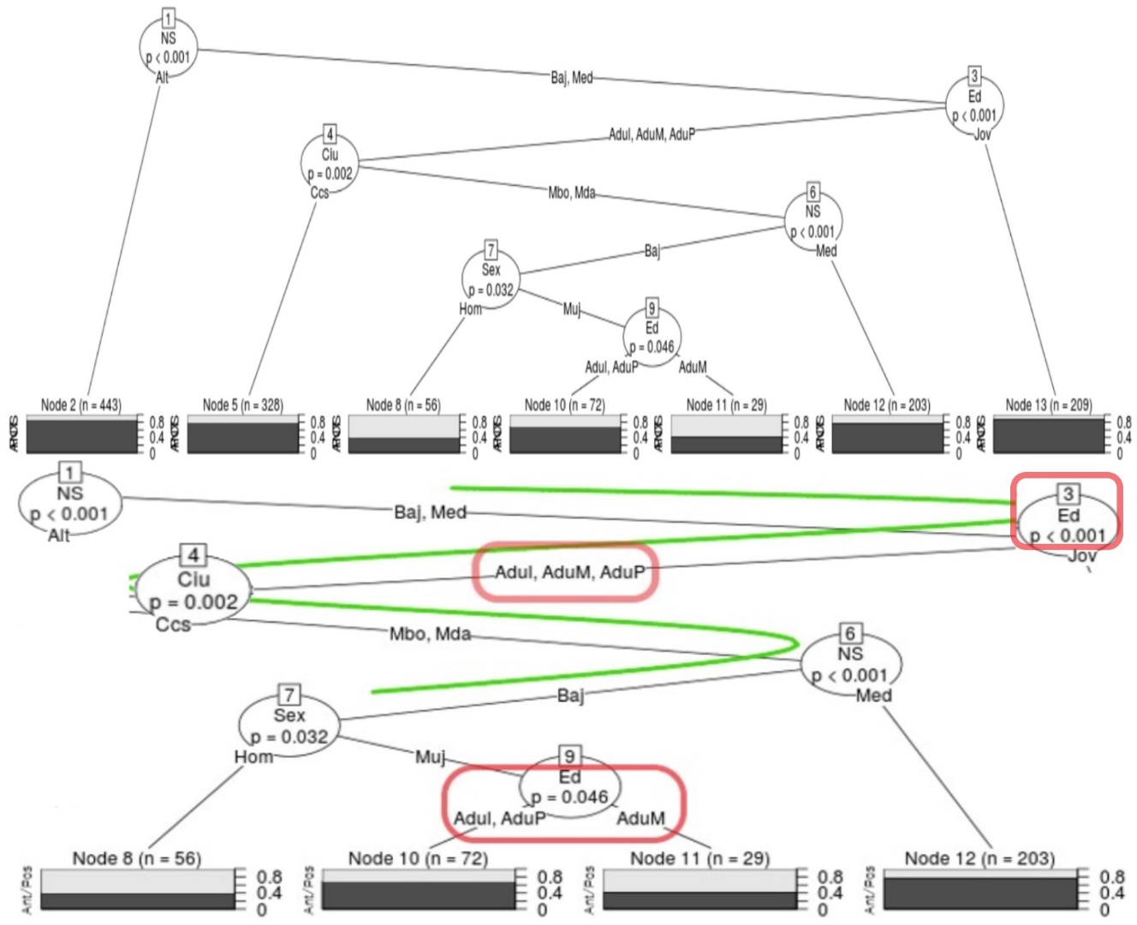
Source: Own elaboration

In the AIC, it is observed that the most relevant factor turns out to be, in fact, the socioeconomic level (Node 1). The tree scheme develops in two directions: to the left of diagram 4, the cases of the high level are concentrated, and, on the right, the associated partitions of the middle and low levels are extended. In turn, speakers are divided into two large age groups (Node 3): young, on the one hand, and all adults on the other. The following partitions divide adults according to city (Node 4); new socioeconomic status (Node 6); sex (Node 7); and, again, age (Node 9).
The incongruity of the data in the regression analysis would then be explained in these partitions. Although adult speakers tilt the crude mean of their group, the interaction restricts their correlation with low-level women from Mérida or Maracaibo. See age group estimates: in node 3, the p-value is below the threshold(p < 0.001), while, in node 9, the predictive effect is clearly close to the established limit (0.046). The random effect surely incorporates these individual differences and adjusts its effect by less than half and, as such, the age group ceases to have significance and thus increases the estimation of the other variables.
Since the choice of random-effects data design is not subject to pre-established criteria (Barr et al., 2013), I did a second analysis without including the age group, which I believe has strengthened the methodological design, since the program's calculations did not show convergence errors with this second model.
Table 9 shows the variables that are most likely to contribute, simultaneously, to the use of the postponed possessive of 1st sg. They are ordered from highest to lowest significance, according to the p-value. Similar to the first model, the five variables were significant, since the values are below the established limit(p < 0.05). The postponement of the possessive correlates strongly with linguistic variables, while the most influential of the external factors is socioeconomic status.
Table 9. Joint contribution of variables to the POS_POS_ 1stsg. – Model 2
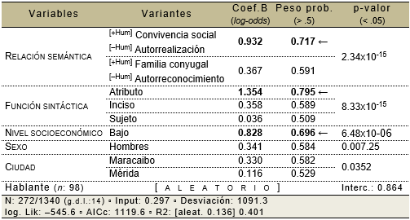
Source: Own elaboration

The second group of data corresponds to probabilistic weights and logarithmic probability or log-odds (Coef. B). Table 9 includes only the factors that favor postnominal use with weights greater than .5 and positive coefficients. According to both indices, semantic relationships expressing social coexistence and self-realization, syntactic attribute function and low level are the variants that register the strongest usage correlation with postponement.
Finally, the categories and numbers specified below Table 9 are related to the fit of the proposed model. The probability (input) that speakers of the three dialects used the postnominal possessive in the decade between 1986 and 1996 is not very high (±30%); however, it is higher than that recorded with the inclusion of the age group (cf. Table 8). By adding the random effect, the interception and variance explained(R²⁾also increase with the second model. The deviation, the logarithm of plausibility (log. Lik) and the Akaike Information Criterion (AICc) indicate that the model provides a good fit and reliable predictions.
In conclusion, the inclusion of the speaker as a random effect – as well as the exclusion of the age group variable – improves correlation rates and prevents age from appearing with an overestimated significance. However, since the proportion of the postponement (large prop.) only reaches 20.3%, the confidence intervals are much wider and no definitive conclusions should be drawn from the analysis.

4.2. Part Two: Other expressive uses of the possessive of 1st sg.
4.2.1. Alternation of the post-adverbial possessive
In the sample, I documented twelve (12) uses of adverbs before me: before (2), near (1), below (1), inside (1), then (3), behind (2), above (2). With postponed possessive I only recorded cases with two adverbs: back (1) and above (2). In (6a) I show the isolated case with back and in (6b, c) the alternation with the cases above:
(6) a. I ran out all over the yard and mom behind me running (MB-A1FB)
b. I felt... that he was going lay on top of me, right? (MB-C3FA)
c. and the ox passed me, passed over me (MD-D5FB)

Additionally, I found three statements with locutions that can be used with the posesive before, with the tonic postponed or with the group of me. In the corpus, behind 'behind' and next to 'near' alternate only with the anteposed and postponed (7a-d); while within reach and in sight – both 'near' (7e) – they only do so with the anteposition; finally, except it is recorded only with the postponed (7f):
(7) a. if you think you can treat her behind my back,treat her (CA-A5MA)
b. if he does it will do it behind my back, I do not know, and I do not know (CA-A5MA)
c. is always by my side when I need him (MD-A1FB)
d. Buton myside, there have been no problems (CA-D5FA)
e. I have something to me... so, to me ... in my sight, within my reach,I grab it (CA-A5FA)
f. was quite strong for us, I would say except for mine (CA-B3MA)

4.2.2. Alternation of the postverbal possessive
In the corpus, there are not many cases in which the appreciative possessive alternates with prepositional groups headed by the prepositions of/by me. I registered nineteen (19) clauses with a verbal core that governs the prepositional group of me: remember (5), fall in love (2), mock (1), complain (1), take over (1), depend (2), talk (1), take possession (1), remember/want/know + GN (3), beingaware/inlove (2); while I only found one case with knowing + GN + possessive postponed. In (8a,b) I offer the examples of the only alternation:
(8) a. other people know something about me (CA-B5MB)
b. I don't know anything about him and he [doesn't know] anything about me (MB-B5FB)

Finally, speakers do not usually use the agent complement function to refer to themselves. In the corpus, there are only three cases, one with the prepositional group by me (9a) and two with the tonic possessive (9b,c); the first two belong to the same speaker:
(9) a. everything, all this I did myself, everything prepared,the material, for me (CA-D5MB)
b. That... that's fried mine too, and the floor all, everything, everything (CA-D5MB)
c. she has been... very spoiled,not so much mine, right? (MD-D3FA)

4.2.3. Emphatic possessive (redundant and weighty)
I registered a single (1) case of redundant possessive in the corpus, issued by a middle-class older adult from Maracaibo:
(10) it was usually with my older brother (MB-D3FB)

Instead, I identified a greater number of uses of the ponderative. Table 10 shows that Caracas speakers register the highest number of these emphatic possessives (46%) and most can be replaced by articles (63%); on the other hand, the merideños contribute 31% of cases, most of which can be omitted (59%); meanwhile, maracuchos document fewer uses (23%), evenly distributed between omissible and replaceable (50%):
Table 10. Uses of the weight possessive
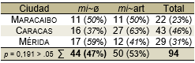
Source: Own elaboration

A good part of these emphatic jobs allows to ratify a habit, custom or routine (swimming, drinking coffee, smoking). As seen in (11), the emphasis is usually reinforced with the use of the diminutive:
(11) a. I give myself my ... zambulladita <sic>from (MB-B3FA)
b. I fry my coffee coroticos,I make my coffee,when I have it (CA-D5FB)
c. when I come with Ana Julia I light my cigarette and she never (MD-B3FA)

In this way, it is often that more than one resource matches to intensify the feature. In (12), for example, speakers turn to some fixed phrases and introduce the weight possessive to intensify the inherent character of the expressed:
(12) a. he gave me my bomb,because from four and a half to five, it was already half an hour nothing more (CA-A5MB)
b. I plan to keep playing, killing my tigritos and so on (MD-A1MA)

Likewise, the weighted quality is usually expressed through material processes:
(13) a. It was fascinating to get on my tram and... and come, wasn't it? (MB-D1MA)
b. I jumped my mecate,we played gargle, hidden (CA-C3FA)
c. I set up my workshop and made the collections and sold them outside (MD-B1FB)

Often, routine practice is associated with entrepreneurship and labor constancy, so the emphasis is on the valuation of work itself:
(14) a. he pushed me with my packets of newspaper on my head (CA-B5MB)
b. working doing my arepas and things and ... seeking life (CA-D5MA)
c. I made a drawer and bought my brush, my creams and I was going to clean my shoe (MD-B5MB)

The evaluative emphasis is also associated with the achievement of an educational stage or achievement or the fulfillment of a duty:
(15) a. I studied my three Intensive English courses,I did them (MB-A1FA)
b. I studied from first to sixth grade and did great (CA-A5FB)
c. I did my pharmacy apprentice,then the assistant and... so (MD-C3MB)

Other jobs appear to reinforce an attribute:
(16) a. And they put on my wings and my sandalitas and my long suit (MB-C1FB)
b. at that time I had my eyesight good. I saw (CA-D5MB)
c. I had my glass ornaments, didn't I? (MD-B3FA)

In other cases, however, it can be used to make an unexpected feature more expensive:
(17) a. I also went in my beast,mounted as if it were male (MB-D3FB)
b. I arrived very campy with my tantrums to my house (CA-A3MA)
c. they provide me... my my passage,and... my hotel stay there, my travel expenses (MD-A5MB)

Next, I present an example in its broad context, which allows us to notice, without further explanation, the affective nuance of the possessive to ponder the flag as the protagonist object of the story and mobile of the emotion transmitted:
(18) if one sees the flag of Venezuela outside one's country, that is for one... well big then, and I remember that... I didn't understand in my first competition outside why the guys, that is, the coach put the flag in front of you, that is, you were competing and they put the flag in the stands... then one... well I remember that in... last year's Central Americans didn't... then I took my flag and put it there... I asked the guys to put it there because we didn't carry a flag and then they put it there, then it gives one more spirit because (MD-A5MB)

Likewise, in the example (19), the use of the possessive allows to enhance the central object of the anecdote, this time, to intensify its humorous scope:
(19) There is a very comical tale ... that happened to my mom, with me. I grabbed once... at that time the ball deodorants began to come out. Then I come <rises>, without saying anything to my mother, and I take the ball out of the deodorant and put the lid back on. And I put it in his bathroom, don't I? <risas>. And I'm going to play metras <risas>with my ball of deodorant,which was acrystalline, because <risas>. Tacatá, tacatá, tá. That night [...] they peeled me because my mom was b.., I was going out that night with my dad, he took a bath and when he went to pour deodorant, I went tossss! he dripped all the deodorant, didn't he? (CA-B1MA)

To conclude the analysis of weight use, I present the absolute frequencies of this employment according to social variables:
Table 11. Uses of the weighted possessive according to social variables
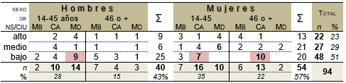
Source: Own elaboration
Table 11 shows that half of the cases are registered in the low socioeconomic level (51%); likewise, speakers between 14 and 45 years old are those who add the highest percentages of use (63%). The women use a little more the weight possessive in the sample, most of them are lower class Caracas; however, the merideñas of the middle and upper classes, although less, also contribute to employment. Men, on the other hand, concentrate the largest number of cases at the low level; being the Andeans of this social class who contribute a substantial number of weights. The correlation between age and socioeconomic status can be seen in diagram 5:
Diagram 5. Correlation of social factors with the weight possessive
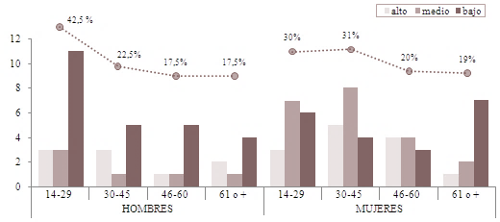
Source: Own Elaboration

The percentages expressed in the columns clearly show the contribution of lower-class men to use; while the curve located at the top of diagram 5 – corresponding to the total percentages by age group in both sexes – indicates the progressive decrease in weight use with increasing age.

5. Final considerations
The analysis carried out shows that the use of the postnominal possessive is due to the joint effect of linguistic and extralinguistic variables. The semantic relationship of the modified noun is the linguistic predictor that most strongly conditions this use in the three dialects. The result coincides with other studies, both in the speech of the Venezuelan variety, and in that of other American cities.
However, the most relevant observation, from my point of view, has to do with the nature of the personal bonds that express these relationships. Except in the case of the filial relationship, the preference of speakers to postpone the tonic form increases when the possessed entity expresses non-parental social relations.
In this way, the generalization that the postnominal possessive tends to be used with nouns that denote kinship relationship is questionable, since the preference of speakers to postpone the tonic form decreases when the possessed entity expresses relations of ascending consanguinity. Since this type of noun does not denote true possession, it is valid to assume that the use responds to the need to emphasize some other inference associated with the personal bond.
The speaker is subject, consciously or unconsciously, to the idea of the common good, of social welfare oriented towards the progress of people, with which, and under the expectation of an interview, it is not surprising that he tries to express himself in terms of personal development and focuses his expressiveness on those entities closest to individual utility, marking especially those that express particular purposes(my longing)and self-realization (mychariot).
The use of the postnominal possessive is, therefore, a way of con/rea-signing, through ownership and belonging, social positioning, either relationships (I have a marital core, employees, love success), or a stable emotionality and assets. It makes sense, then, that those who make the greatest use of this expressive resource are the speakers of lower social class and the older ones, both subject to the pressure of a society in which success is measured, generationally, in thermal of possessions, achievements and personal contacts.
Although less frequent, the pragmatic function of emphatic possessives also allows us to ponder a repetitive or unexpected characteristic and is a productive expressive resource in the speech of young people, especially lower-class Caracas.
Regarding the descriptive relevance of analytical constructs, in the present study I have used the linear regression model of mixed effects and conditional inference trees, two powerful statistical tools that have allowed me to raise the plausibility of the analysis and solve the limitations of the traditional model in terms of the inclusion of the speaker as a source of variation. However, the analysis of the less abundant uses, in their discursive context, allowed me to establish premises on the motivations of their use, useful for future analysis.
Finally, it is worth remembering that the sample analyzed here was collected for study thirty years ago, so similar research in current speech samples is a good opportunity to confirm thesetrends.

References
Aleza, M. (2010). Morphology and syntax. Grammatical observations of interest in American Spanish. The possessives. En M. Aleza & J.M. Enguita (Coords.), La lengua española en América (p.138-144). Universitat de València: Valencia.
Barr, D., Levy, R., Scheepers, C. & Tily, H. (2013). Random effects structure for confirmatory hypothesis testing: Keep it maximal. Journal of Memory and Language,68, 255–278.
Bentivoglio, P. & Sedano, M. (1992). Morphosyntax. Lagoven Notebooks. The Spanish language of present-day Venezuela,46-70.
Bentivoglio, P. & Sedano, M. (1998). Syntactic journey from Catia to Petare. Imagen Magazine,31(1), 127-130.
Bentivoglio, P. (1996). The grammar of Spanish spoken in Venezuela. Language and Speech,1(1), 21-39.
Bertolotti, V. (2014). Possessive pronouns in Rioplatense Spanish: Three cases of reanalysis. Translations, 1, 59-74.
Bouzouita, M., Castillo, M. & Pato, E. (2018). Dialects of Spanish. A new application to know the current variation and the change in the varieties of the español. Dialectology,20, 61-83.
De Stefano, L. & Chumaceiro, I. (1992). The first-person possessives of the singular and plural in the speech of Caracas. In E. Luna Traill (Coord.), Scripta Philologica. Homage to J.M. Lope Blanch (p.823-839). Mexico City: UNAM.
De Stefano, L. (1996). The possessive adjective in the Spanish spoken in Maracaibo. Iberoromania,44, 39-51.
Demonte, V. (2000). Grammar, variation and norm: a typology. Revista Hispánica de Lingüística,12, 3-49.
Eddington, D. (2017). Nominalized adverbs in Spanish: the intriguing case of detrás mío and its cohorts. Research in Corpus Linguistics,5, 47-55.
Freeman, M. (2019). The expression of nominal possession in Medellin,Colombia. Master's thesis. Baton Rouge: Louisiana State University.
Granda, G. (1966). The evolution of the possessive system in Atlantic Spanish. Study of synchronous morphology. Boletín de la Real Academia Española,46, 69-82.
Granda, G. (1997). Rethinking a controversial issue. Genesis and retention of the double possessive in Andean Spanish. Journal of Spanish Philology,77, 139-147.
Guirado, K. (2009). (De)queismo: deictic use and social distribution in Caracas speech. Caracas: CEP/FHE/UCV.
Guirado, K. (2012). Venezuelan is spokenhere. Conversatorio: En defensa del español de Venezuela,Conference, Universidad Central de Venezuela.
Guirado, K. (2015). Reengineering of Corpus in Venezuela: a methodological proposal to diversify the analysis of the corpus of spanish spoken in Caracas, Letras,92, 55-87.
Guirado, K. (2021). CORDIA-VEN-sXX: A dialectal subcorpus for the sociolinguistic study of Spanish spoken in Venezuela. Dialectology 26,45-71.
Guy, G. (1988). Advanced VARBRUL analysis. In K. Ferrara, B. Brown, K. Walters & J. Baughb (Eds.), Linguistic change and contact (p.124-136). Austin: University of Texas.
Johnson, D. (2009). Getting off the Goldvarb Standard: Introducing Rbrul for Mixed-Effects Variable Rule Analysis. Language and Linguistics Compass,3(1), 359-383.
Lapesa, R. (1971). About the article ante possessive in old Castilian. In E. Coseriu & W. Dieber Stemple (Eds.), Sprache und Geschichte. Festschrift für Harri Meir zum 65 (p.277-296). Munich: Wilhelm Fink Verlag.
Ledezma, M. de & Barrera, L. (1985). Some morphosyntactic phenomena of the speech of Venezuela. Letters,43, 139-222.
Ledezma, M. de & Obregón, H. (1990). Grammar of The Spanish of Venezuela. Caracas: IPC.
Lo Ponte, C. (2016). Analysis of the variation of Spanish in Venezuela through video and recordings. Degree thesis. Padua: Università degli Studi di Padova.
Marttinen, M. & Bouzouita, M. (2018). On top of me vs. above me:a variationist analysis of the adverbial constructions thecativas with prepositional and possessive complements on Twitter. Modern språk, 112(1), 1-39.
Maslow, A. (1943). A Theory of Human Motivation. Psychological Review,50, 370-396.
Murguey, A. (2010). The descriptive locative adverb: syntax and semantics in Venezuelan Spanish, Letras,52(81), 49-67.
Navarro, M. (2001). The prepositive adverbs in the speech of Valencia. Letters,62,55-79.
Orozco, R. (2010). Variation in the expression of nominal possession in Costeño Spanish. Spanish in Context, 7(2), 194-220.
Pacheco, C. & Bouzouita, M. (2017). The use of possessive pronouns in havana youth speech: a variationist analysis. In L. Ruiz, M. Álvarez & A. Muñoz (Eds.), Nuevos Estudios sobre Comunicación Social (p.52–56). Santiago de Cuba: Center for Applied Linguistics.
Paolillo, J. (2013). Individual effects in variation analysis: Model, software, and research design, Language Variation and Change,25, 89-118.
Picallo, M. & Rigau, G. (1999). The possessive and possessive relationships. In I. Bosque & V. Demonte (Dirs.). Descriptive Grammar of the Spanish Language (973-1023). Madrid: Espasa Calpe.
Pons, S. (2014). The twentieth century as a diachrony: intuition and verification in the case of that is. RILCE, 30/3, 985-1016.
Porto-Dapena, J. (1982). The personal possessives of Spanish: attempt at functional description. Dicenda,1, 55-108.
Radelli, B. (1978). The possessives in Spanish. New Journal of Hispanic Philology,27, 235-257.
RAE & ASALE. (2005). Pan-Hispanic dictionary of doubts. Madrid: Santillana.
RAE & ASALE. (2009). New grammar of the Spanish language. Madrid: Espasa-Calpe.
Salgado, Á. & Bouzouita, M.(2017). The use of locative adverb constructions with possessive pronoun in peninsular Spanish: a first diatopic approach. Zeitschrift für romanische Philologie,133(3), 766-794.
Sanchez, C. (2008). The possessive determinants in Costa Rican spoken Spanish. Philology and Linguistics XXXIV, 1, 193-208.
Santana, J. (2014). The adverb+possessive structure in digital media. Current Spanish,101, 7-30.
Satorre, F. (1999): Los posesivos en español. Valencia: Universitat de València.
Scrivner, O. & Díaz-Campos, M. (2016), Language Variation Suite: A theoretical and methodological contribution for linguistic data analysis. Proceedings of the Linguistic Society of America,1(29). Retrieved May 14, 2017, http://journals.linguisticsociety.org/proceedings/index.php/PLSA/article/view/3734.
Silva-Corvalán, C. & Enrique-Arias, A. (2017). Sociolinguistics and pragmatics of Spanish. Georgetown UP: Georgetown University Press.
Solkoff, K. (2002). The pronouns of subjectivity: first and third person in the context of cognitive psychotherapy. Subjectivity and cognitive processes,2, 214-229.
Strobl, C., Malley, J. & Tutz, G. (2009). An Introduction to Recursive Partitioning: Rationale, Application and Characteristics of Classification and Regression Trees, Bagging and Random Forests. Psychol Methods,14(4), 323–348.
Tagliamonte, S. & Baayen, H. (2012). Models, forests and trees of York English: Was/were variation as a case study for statistical practice, Language Variation and Change, 24, 135-178.
Ugueto, M. (2015). "Y me comí mis caraotas": Use of the possessive atone in Caracas Spanish. Sapiens,16(1), 77-101.

* I thank Matti Marttinen and Miriam Bouzouita for their timely and pertinent remarks. Needless to say, all errors that remain in this contribution are entirely my responsibility.
This interpretation has been previously pointed out, among others, by Radelli (1978) and Porto Dapena (1982).
Porto Dapena (1982), Satorre (1999), among others, also Mentioned the emphatic quality of the possessive anteposed.
Envelope this structure, cf. Granda (1966, 1997), Lapesa (1971) and the abundant contribution of Concepción Company Company – available at: http://www.concepcioncompany.com/.
Alternation occurs with other prepositive or adverbial discursive particles: in my place~instead of me/mine; of my part~part mine; to my weigh~weigh of me/mine (cf. Picallo & Rigau, 1999).
Since the beginning of the twentieth century, andstos uses have been documented in peninsular and American speeches by various Studies dialectological. Works Recent confirm its extension: Aleza (2010); Bertolotti (2014); Santana (2014)); Eddington (2017); Salgado and Bouzouita (2017); Marttinen and Bouzouita (2018); Bouzouita, Castle and Duck (2018).
For example, lthe website of the Cervantes Virtual Center hosts the space By speaking. Museum of Horrors. In this "terrifying Museum" there are two Phenomena: the use of possessives with adverbs and the use superfluous to refer to the inalienable possession. Also, all the entries of the locative adverbs of the Panhispanic Dictionary of Doubts include the tagline: "its use with possessives is not considered correct" (RAE & ASALE, 2005).
As Solkoff (2002, p. 215) says poetically: "Where the Third Person transits a paradigmatic architecture of neatly symmetrical statements and escapes from the intentional alleys of subjectivity, the First Person threads with mentalistic threads a singular plot, challenging inaccessible routes, proclaiming his authority in a mysterious language."
Cf. Guirado (2015) on the notion of corpus reengineering, and cf. Pons Bordería (2014) on the microdiacrony.
In addition to those described in §3, I also ruled out the cases of the postponed possessive when it is mandatory, since alternation is not documented in Venezuelan Spanish. A know: with indeterminate article (one/other/six friends mine); with demonstrative (this friend mine); as an argument of have (there are friends Mine); or with quantifier (was a good friend mine), except in cases with the floating quantifier all-to-s, which allows alternation.
The code at the end of the examples describes the stratification of the speaker: i. city: mb, ca, md = Maracaibo, Caracas, Merida; ii. age group: a, b, c, d = 14-29/30-45/46-60/61 or more years; iii. socioeconomic status: 1, 3, 5 = high, medium, low; iv. sex: m, f = male, female; v. identification of each speaker within the box: a, b.
Categorization is based on the hierarchy of human motivation (cf. Maslow, 1943).
This for the purpose of ensuring the demonstrative strength of correlations (Cf. Demonte, 2000; Guirado, 2009).
Although the data have been sufficiently adjusted, the occurrences do not exceed 97 statements.. For Paolillo (2013), p. 97)andl margin minimal to perform a random-effects analysis is "100 tokens per speaker”.
This procedure allows you to visualize the complex interaction of variables because it estimates the distribution of usage across a recursive partition (cf. Strobl, Malley & Tutz, 2009; Tagliamonte & Baayen, 2012).
Paolillo (2013, p.97) supports the methodological decision to exclude factors or create subgroups of the sample, provided that these methodological assumptions contribute to the interpretation of the data: "We will come to see that the data do not strongly determine the results of the statistical analysis and that certain assumptions, the selection of which should be guided by the research design, are every bit as important".
Weights indicate the statistical significance of the variants, while the B coefficients Express the degree of association and the power. Unlike probabilistic weight, this index offers a balanced trend measure, when the coefficient B is positive, the intensity of the relationship between the category and the postponement is greater.
I've named it ponderative because I share the interpretation of Fernández Ramírez ([1951]1987, p.91): "use of the same atone forms for expressive purposes, use that in the colloquial and popular style reaches extraordinary development, with the most varied nuances of tenderness, irony, price, etc. The value of the possessives is close in some of these cases to that of the quantitative and weighty indefinite."

