Assessment of students on the usefulness of subjects related to Linguistics in the first year of the degree in Translation andInterpreting.

Students' opinion on the usefulness of subjects related to Linguistics in the first year of Translation and Interpretation degree.

DOI: 10.32870/sincronia.axxv. n80.23b21

Cristina Rodriguez Faneca
Area of Library And Information Science. University of Córdoba (SPAIN).

Sergio Rodriguez Tapia
General Linguistics Area. University of Córdoba (Spain).
EC: l02rotas@uco.es

This work is licensed under a Creative Commons Attribution-NonCommercial 4.0 International License

Received: 27/10/2020

Revision date: 30/04/2021
Accepted: 12/05/2021

SUMMARY.
Research on attitudes towards learning a certain subject stands today as a scalable analysis instrument that allows to promote improvements in the didactic approach in a precise way and adjusted to the particularities of teaching. This work constitutes an exploratory and descriptive study that aims to investigate the attitudes of students of the different itineraries of the first year of the Degree in Translation and Interpretation (TeI) of the University ofCórdoba, towards several subjects related to Linguistics. Within this subject, four groups of students with a different training profile are enrolled. Specifically, this study focuses on analyzing the affective component of the attitude through the assessment of usefulness granted by the students towards these subjects. This evaluation was carried out through a survey carried out in two different periods, before and after the teaching of this subject. The results suggest the need to rethink certain topics within the subject, since the main differences in the opinion of usefulness and the evaluations of the subjects could correspond to the disparity of socio-professional and academic motivations of the students.

Keywords: Attitude. Linguistics. Motivation. Translation.

ABSTRACT.
Research on attitudes towards the learning of a certain subject now stands as a scalable analysis tool that allows for improvements in the didactic approach in a precise way and adjusted to the particularities of teaching. This paper is an exploratory and descriptive study that aims to investigate the attitudes of students from the different itineraries of the first year of the Degree in Translation and Interpretation (TeI) at the University of Córdoba towards various subjects related to linguistics. Four groups of students with a different formative profile are enrolled in this subject. Specifically, this study focuses on analysing the affective component of the attitude through the evaluation of the usefulness given by the students to these subjects. This evaluation was carried out through a survey conducted in two different periods, before and after the teaching of the subject. The results suggest the need to reconsider certain issues within the subject, since the main differences in the opinion of usefulness and the assessments of the subjects could match the variety of socio-professional and academic motivations of the students.

Keywords: Attitude. Linguistics. Motivation. Translation.

Introduction and theoretical framework
Research on attitudes towards learning a certain subject stands today as a scalable analysis instrument that allows to promote improvements in the didactic approach in a precise way and adjusted to the particularities of teaching.
The typology of this type of research is diverse, since we find studies focused on measuring attitudes towards a specific subject (Comas, Martins, Nascimento & Estrada, 2017; Marbá-Tallada & Márquez, 2017; van Aalderen-Smeets & van der Molen, 2013), works on the measurement of a certain attitude in relation to a specific phenomenon (Abellán, 2017; Zampieron, Corso & Frigo, 2010; Hanna, 2009) or research focused on the construction and validation of scales for the subsequent analysis of a certain attitudinal phenomenon (Fuentes, Errázuriz, Davison & Cocio, 2019; Traver-Martí & Ferrández-Berrueco, 2016). Other studies are aimed at investigating the usefulness or importance given by students towards certain subjects (Sabra, 2018), including Linguistics (Attardo & Brown, 2005).
Regardless of the type of study, we must emphasize the existence of a constant. Most of them refer to the need to take into account the affective component of attitudes in pursuit of more effective learning (Damasio cit. in Arnold, 2019,p. 27). This is often qualified in research whose objective is to discern the motivations of students in relation to a given subject (Ramos & Gómez, 2019; Minera-Reyna, 2010). Not surprisingly, emotions are pointed out by many authors as an engine of attitudes (Cohen and Wang, cit. in Pinilla-Herrera & Cohen, 2019,p. 42) that the teacher has to propel (Marquès, 2001) through the use of appropriate didactic strategies.
In the case of the subject at hand, Linguistics, it is important to take into account the affections and motivations of the students due to its intrinsic complexity (concretized in a proposal of polyhedral contents, which covers contents of areas such as Discourse Analysis, Phonetics and Phonology, Morphology or New Technologies, among others) and the various orientations that can be conferred on the subject within each of the degrees where it is taught. This diversity points to the multiplicity of conceptions, attitudes and emotions that are involved in the acquisition of content. Therefore, the enhancement of the attitudes of students of various degrees can allow, ultimately, the adaptation of methodological strategies in each of the degrees with the aim of adapting and perfecting the teaching-learning process.
Affective aspects of the teaching-learning process
Attitudes towards learning
As Estrada (2007, p. 122) points out, attitudes towards learning a subject seem to be an entity that is difficult to define. Proof of this is the multiplicity of definitions, contexts and conceptions that can be found in relation to this object of study. For Thomas and Znaniecki, pioneers in the study of attitudes in the field of Social Psychology, attitudes involve individual mental processes that determine both "the real responses and the potential responses of each person in the social world" (Thomas and Znaniecki, cit. in Allport, 1935, p. 798).
In the field of Educational Psychology, attitudes suppose, for Gal and Garfield (cit. in Estrada, 2007, p. 122), "a sum of emotions and feelings that are experienced during the learning period of the subject under study", while for López and Auzmendi (2018) attitudes are generated even before the learning period, as it is "a predisposition, with a certain emotional charge, that influences behavior" (p. 233). These beliefs can be positive or negative (Briñol, Falces & Becerra, 2007, p. 463), or neutral. They can, in turn, be directed towards a part of the subject, independently of the rest; therefore, it is also possible that attitudes are adjustable in intensity and that this intensity and character is reflected in specific activities or in the teaching staff of the subject (Estrada, 2007, p. 123). It has been found that these beliefs, if previously acquired, tend to be favorable at first and also tend to follow a negative evolution that lasts over time (Callahan, Suydam & Aiken, cit. in Estrada, 2007, p. 123).

Components of attitudes
As with the concept of attitude itself, there are multiple perspectives on its scope and on the components that make it up. According to Hanna (2009,p. 145), one of the difficulties inherent in the study of attitudes is that it challenges, in a certain way, the possibility of an empirical observation, since it is entirely with the intrinsic experience of an individual.
Some binomial perspectives, such as the one reviewed in Marbá-Tallada & Márquez (2010, p. 20) point to the existence of internal factors (such as age, gender, influence of parents, etc.) and external factors (teaching methodology, classroom environment, teaching planning, etc.).
Other conceptions of attitude expand and detail the number of factors or components involved in its generation; thus, we find a triadic conception of attitudes (Briñol, Falces & Becerra, 2007, p. 459) nuanced in affective components (such as feelings and emotions), cognitive (thoughts, ideas and beliefs) and behavioral (manifest actions in relation to the attitudinal object). In other studies, the conative or intentional component is also added, a component prior to the nuance of the behavioral component. The scale proposed by Auzmendi (1992) deserves special mention, where the utility factor appears within the affective components, understood as a value granted that the student confers to the usefulness of the subject in question in his future professional life.
Gómez-Chacón (2016, p. 94) confirms the importance of the interaction between affective and cognitive components during learning. Ultimately, the review of the scientific literature confirms the possibility of acting on some components (cognitive, especially) to modify the perception of others (affective and behavioral). This possibility is explained through the relationship between attitudes and a possible change in them through modifications in the factors of the teaching-learning process that depend on the teacher.

Affective aspects of the teaching-learning process
The didactic act is a very complex process in which various components interact (Marquès, 2001) whose central pieces are student and teacher. In this sense, the teacher plans a series of activities with the aim of achieving certain educational results; for his part, the student interacts with the training resources that are provided to him to achieve these objectives with the help of the teacher. But this act is concretized with the help of a context in which planning, content and evaluation, in addition to didactic strategies, have a fundamental role.
The didactic strategies proposed by the teacher must provide students with motivation, information and guidance in order to achieve learning outcomes (Marquès, 2001). To do this, they must take into account a series of principles whose typology is diverse; we could consider, in principle, some conjunctural factors such as the available didactic materials, the selection of methodology or the temporal organization of learning.
However, the didactic strategy must also take into account a whole series of personal and affective factors such as the motivations and interests of the students, as well as their idiosyncratic characteristics. Not surprisingly, Foss & Kleinsasser (1996) pointed to the lack of study of the relationships between the teaching-learning process and the affections of the student as factors that have a negative impact on this process. Several subsequent works corroborate the importance of the study of this relationship (Smith, 2019; Moreno, Rodríguez, & Rodríguez, 2018).
The study of attitudes undoubtedly allows teachers to gather information about the motivations of students in pursuit of concrete actions (van Aalderen-Smeets & van der Molen, 2013, p. 597). All this is based on the conception that the didactic act is, in reality, a communicative act (Heinemann, 1980) that goes beyond the content that must be assimilated and, therefore, beyond the message itself. Meneses-Benítez (2007, p. 57) points out that, in this context, it is necessary to use different didactic strategies with a flexible character, so that these strategies allow a greater perceptual richness and, therefore, a greater motivation and adaptation to the idiosyncrasy of the student.

Objectives
The main objective of this work is to inquire about the perceptions of usefulness and importance about the subject of Linguistics in students of various degrees (Degree in Translation and Interpretation and three double itineraries associated with this degree with the Degree in Hispanic Philology, the Degree in Tourism and the Degree in English Studies).
In this way, it is also intended to approximate the different didactic implications that can be derived from these attitudes and motivations when addressing the subject in each of the itineraries. To this end, the following secondary objectives are intended to be achieved:
–Compare the ratings and opinions on usefulness between the different degrees.
- Compare changes in ratings and opinions on usefulness between the two periods analyzed.

Methodology
Subject under study
This study has an exploratory and descriptive character that aims to analyze in a panoramic way the attitudes of the students of Linguistics of the Degree in Translation and Interpretation and their joint itineraries of the University of Córdoba before the subjects they study in this subject.
The subject in question, taught in the first year, is a basic subject common to the four groups surveyed, so that they share evaluable competences, evaluation systems, contents and teaching methods. Among the objectives of Linguistics are to improve oral and written competence in Spanish or to analyze in a scientific, critical, systematic and interrelated way the basic theoretical contents that underpin the levels of analysis of languages, theoretical models and general reflection on language throughout history, and the various disciplines of the applied side of Linguistics.

Design, participants and procedure
The study population is made up of students enrolled at the University of Córdoba during the 2019/2020 academic year in the subject of Linguistics of the Degree in Translation and Interpretation. This is a convenience sample made up of women (84.26%) and men (15.73%) whose ages range mainly between 17 and 25 years (97.37% of the total number of participants). The study was carried out in two periods: the first, in the month of September, coinciding with the beginning of the academic year and the semester; the second, in December 2019, when the subject in question finished being taught. The chronology of the survey responds to the intention of knowing the preconceptions of the students (in September, before the teaching of the subject) and its possible variation at the end of the subject.
The participants of this study were 160 and 142 students (in the first and second period, respectively) out of a total of 230 enrolled in the degrees of Translation and Interpretation and the three double itineraries, related by acronyms in Table 1. Figure 1 lists the number of students enrolled and, subsequently, the number of students who participated in the surveys in each of the periods (it should be noted that the number of students on the joint itineraries is much smaller than the simple itinerary and never exceeds thirty).
Table 1. Acronyms of the degrees analyzed.
Titration | Acronym
Degree in Translation and Interpreting | Tei
Degree in Translation and Interpreting and Degree in Hispanic Philology | TeI+FH
Degree in Translation and Interpreting and Degree in Tourism | TeI+Tourism
Degree in Translation and Interpreting and Degree in English Studies | EEII+TeI
Source: Own elaboration
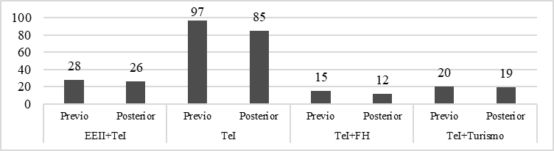
Figure 1. Number of surveys answered by periods and degrees.
Source: Own elaboration
Instrument
Although there are multiple methods to measure attitudes (such as differential semantic scales, projective tests or direct interviews). The Likert Scale shows several advantages compared to the rest of the methods (van Aalderen-Smeets and van der Molen, 2013, p. 585); among them, the possibility of being completed online comfortably by a high number of participants, or include a large number of items. The data collection instrument chosen for this study was a questionnaire organized in 3 parts. This questionnaire was designed ad hoc and was validated by experts from three different areas of the University of Córdoba: General Linguistics, Library and Documentation and Didactics and School Organization.
- In the first part of the questionnaire, informative data of the student is collected, such as age, gender or the degree to which he belongs.
- In the second part of the questionnaire, the student is asked to assess, using a Likert scale of 1 to 4, the usefulness of the 10 subjects on which the query is concerned by means of the following statement: "Indicate your degree of agreement /disagreement with the following statements (on a scale from 1 to 4, where 1 is "completely disagreed", 2 is "disagree", 3 is "agree", and 4 "completely agree") in relation to the usefulness that you consider each of the areas of linguistics proposed to have when carrying out your professional work: I consider that the knowledge of ___________ will be useful to me when carrying out my professional work", where the blank space is completed with one of the 10 subjects under analysis.
- Finally, the student can justify their choices through an open answer question associated with each item according to the following statements:
  - «Of the areas mentioned above, indicate which one you consider most useful for the performance of your professional work and why»
  - "Of the areas mentioned above, indicate which one you consider least useful for the performance of your professional work and why."
During the presentation of the results of our study, this last contribution of the students complements, punctually, the results of the second part of the questionnaire, although they are not the object of systematic analysis in this work.

Data analysis
This study analyzes five different variables, which combine to identify the different relationships:
- Titration: it has four nominal and exclusive values according to those indicated in Table 1.
- Period: divided in binary form into before and after,coinciding with the questionnaire completed in September or December.
- Assessment: with an ordinal quantitative character of 1 to 4 (less useful or more useful, respectively), applied to the 10 subjects analyzed, which are indicated in Table 2 along with the acronyms that will be used throughout the work.
- Subject considered most useful in the student's training: with a nominal and exclusive character, each student chooses a single subject among the 10 possible as a subject considered most useful in their training development.
- Subject considered less useful in the student's training: with a nominal and exclusive character, each student chooses a single subject among the 10 possible as a subject considered less useful in their training development.
Table 2. Acronyms of the subjects analyzed.
Matter | Acronym
Discourse analysis | AD
Phonetics and phonology | FF
Lexicology and semantics | LS
Morphology | M
Language teaching methodology | ME
New technologies | NT
Pragmatics | P
Psycholinguistics | PSI
Syntax | S
Terminology and lexicography | TL

It is worth pointing out the conception of greater or lesser usefulness in this consultation, which was reviewed with the students before the survey was completed:
- however useful,students understand that subject with an essential character, without which they could not carry out their professional or academic work;
- for less useful, students understand that expendable subject in their training, given its complementary nature or little related to their professional or academic expectations.

These conceptions of utility are in line with those of Auzmendi (1992) and Gómez-Chacón (2016), who include the utility factor within the affective components that have more relevance when interacting with the cognitive component during the learning process.
For the analysis of the quantitative data, the SPSS statistical software was used. After structuring the data, a descriptive analysis was carried out by studying the frequencies and percentages. Subsequently, the qualitative information was analyzed through a documentary content analysis (Pinto, Gálvez & Dijk, 2018).

Analysis and discussion of results
Usefulness and general assessment of students
Graph 2 relates the percentage of student responses around the most useful subjects in their training (each student opts for a single answer of the possible ones). In this case, we compare the responses at the beginning and end of the semester. As can be seen, the most relevant subjects are language teaching methodology (28.99%-22.68%), discourse analysis (16.67%-13.40%) and pragmatics (5.80%-25.77%).

Figure 2. Comparison of students' opinions on more useful subjects in their training in different periods.
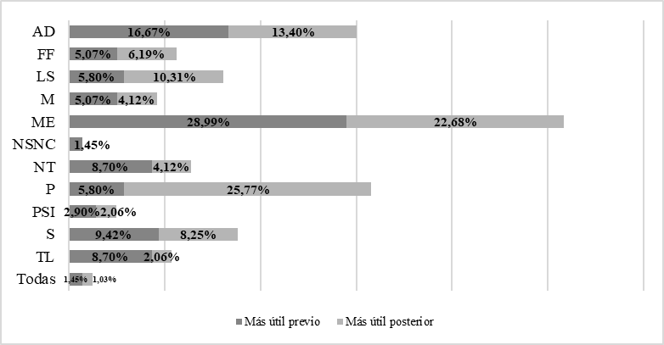
Source: Own elaboration

In the case of pragmatics, according to the results of the subsequent survey, it is the subject considered most relevant by 25.77% of students: the difference that exists of almost 20 points between the previous and subsequent survey stands out, which represents the largest difference of the entire survey (since it multiplies by 4.44 its initial assessment). It would be possible to glimpse two reasons: (a) the lack of knowledge of the subject on the part of the students when carrying out the previous survey; or (b) the theoretical and applied value that TeI students find about pragmatics in their training, which has caused them to consider it as a subject of more importance than others of those who have previous knowledge for their secondary studies (for example, morphology or syntax). In general, all assessments of utility decrease, with the exception of lexicology and semantics and pragmatics, which have a significant difference between periods. We could consider that the relevance of pragmatics in the subsequent survey has added part of the useful opinions that at the beginning of the semester the students gave to other subjects.
Pragmatics is followed by the methodology of language teaching, which, despite declining in its consideration as an essential subject, stands out far above the rest. Some reasons provided by students regarding the usefulness of this subject in their training are related to the fundamental nature of understanding the non-native linguistic system, although, in our opinion, the fact of 'learning a foreign language' is usually confused with the subject responsible for reflection on what theories and methods are used in the teaching-learning of languages. In addition, it is worth highlighting the fact that the subject of lexicology and semantics, despite being the fourth most outstanding subject, is the one that, after pragmatics, most increases its consideration as a useful matter: it goes from 5.8% to 10.31% (multiplied by 1.78 its initial assessment). Some of the reasons that students put forward about the importance of this subject in their degree have to do with the types of meaning and the concept of meaning (meaning in context), a notion closely related to pragmatics. Thus, at first glance, a general reasoning could be inferred around the importance that students attach to factors that influence communication, such as the context or the receiver, and the need they perceive to have tools to solve the problems that affect translation, that is, to give pragmatics an instrumental value.
If we cross these useful data with the assessment on 4 that each student assigns to each subject, we obtain Graph 3,which has an average of previous evaluations of 3.41 and subsequent evaluations of 3.33 out of 4. This graph shows that none of the subjects is valued below 3 on any occasion, so it follows that students consider that all subjects are relevant in their studies to a greater or lesser degree, although they choose to underline one in front of the other.

Figure 3. Difference of opinions of the students on more useful subjects in their training and their evaluations in the two periods.
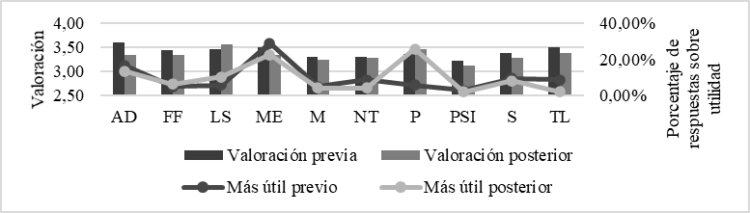
Source: Own elaboration

The previous survey shows that the best valued subjects coincide in part with those considered most useful, such as discourse analysis (3.6) and language teaching methodology (3.51), followed by terminology and lexicography (3.5) and lexicology and semantics (3.43). On the other hand, the subjects with the best subsequent assessment coincide with those that increase their consideration of usefulness in Graph 2,that is, lexicology and semantics (3.56) and pragmatics (3.45). To these is added the methodology of language teaching (3.35) and terminology and lexicography (3.38), which despite increasing their valuation do not grow in their consideration of useful subjects. It can be seen that the main difference is in the relevance of pragmatics to the detriment of discourse analysis, despite being closely related subjects, given the epistemological relevance of the factors of the communicative situation in the two subjects.
In contrast, Figure 4 presents the results around the considerations of subjects with less utility (which does not necessarily imply that they are valued negatively, but are not considered essential in their training and subsequent professional practice). In this case, new technologies (19.59%), psycholinguistics (15.46%) and syntax (12.37%) stand out, which generally maintain the percentage of evaluations on their usefulness in the two periods we analyzed. This means that the opinion of the students around these subjects does not change significantly at the end of the subject. Some of the justifications provided by students are related to the lack of application or lack of need in their training, which, in our opinion, conflicts especially with the necessary professional skills related to new technologies.

Figure 4. Comparison of students' opinions on less useful subjects in their training in different periods.

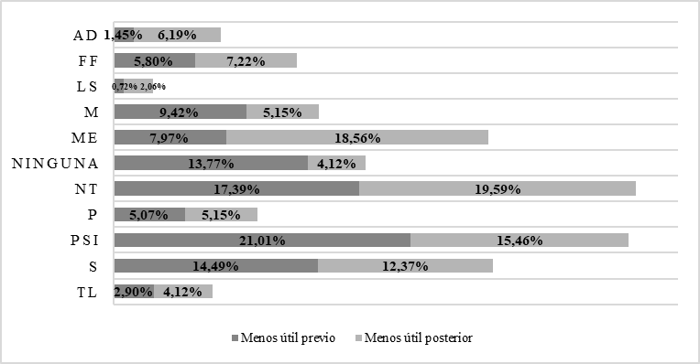
Source: Own elaboration

One of the data is striking, related to the increase in the percentage of less usefulness of the subject language teaching methodology, which goes from 7.97% to 18.56%, which means multiplying by 2.33 the initial value. It stands out especially if we compare it with the results of Graph 2,in which it stands out precisely for its usefulness. In this case, the evaluations are very polarized and reflect that some of the students who considered in principle that none is less useful subsequently chose to take into account the lack of usefulness of the subject of language teaching methodology. Psycholinguistics, new technologies and syntax are also three of the subjects with the lowest ratings according to the surveys: 3.12, 3.28 and 3.27 respectively, which already suggests some very relevant pedagogical implications, as it is necessary to identify the causes that cause such assessment and the consideration of unhelpful subjects.
In addition, in another order of things, it is worth highlighting the role of discourse analysis, which, although it does not lead the subjects considered less useful, the change in valuations (from 1.45% to 6.19%) represents a growth of more than four times with respect to the initial value. In our opinion, this may be related to what has been pointed out above in relation to the role of pragmatics, a matter closely related to discourse analysis, which may lead to the less useful consideration of discourse analysis contrasting with the more useful consideration of pragmatics.

Usefulness and valuation according to degrees
Next, we focus our attention on the most polarized cases that have been identified in the previous section: the subjects considered more useful and less useful. In this section we analyze the ratings of 1 to 4 granted by each student according to the four groups of students who have completed the survey. It should be stressed that the growth of evaluations in the subsequent survey does not necessarily imply that the students consider this subject as the most important in their training.
The data presented from Figure 5 to Figure 12 gather the assessments of the subjects considered most useful. To the right of each assessment graph by degree is the evolution of the usefulness of each subject according to these degrees. In the graphs on the right, each block of the same color adds up to 100% with the rest of the blocks of the same color within the same degree, so you should never compare, for example, the green blocks within a graph that presents information of different degrees, but within the results for the same degree.

Figure 5. Assessment of pragmatics according to degrees
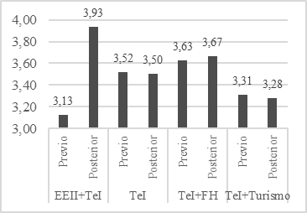
Source: Own elaboration

Figure 6. Comparison of the usefulness of pragmatics according to degrees and periods
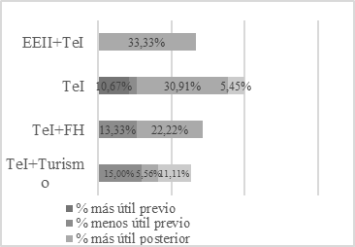
Source: Own elaboration

In the first place, it is observed that the assessment of pragmatics is very similar in the two surveys in all degrees except eeii + TeI, whose change in assessment seems very relevant. So much so that, as can be seen in Figure 6,33.3% of respondents subsequently consider pragmatics to be the most important subject of the subject of Linguistics (that is, it is never recorded as less useful). Initially, the justification for this change could be related to a smaller number of surveys answered, which would increase the density of positive evaluations, although the other two joint itineraries also have a number of similar surveys. Therefore, it would be convenient in future work to analyze the justifications or causes that lead this specific group to change its assessment of pragmatics in such a relevant way. Another relevant fact is the fact that, despite maintaining the scores of the assessment of pragmatics in the other three degrees, in two of them the number of opinions about its usefulness in the subsequent survey increases considerably, which reflects that there must be a conventional justification for such a change, which would be convenient to analyze in future works.
In contrast to the consideration of EEII+TeI, TeI+Turismo is the itinerary that is in the last place in the assignment of utility to pragmatics, which may be related to the data represented by the degree in Graph 8, which considers the language teaching methodology more useful.

Figure 7. Assessment of the methodology of teaching-learning of languages according to degrees.
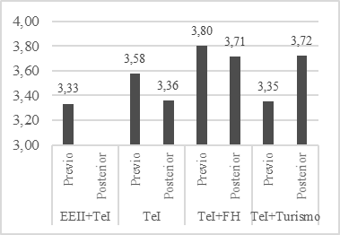
Source: Own elaboration

Figure 8. Comparison of the usefulness of the language teaching-learning methodology according to degrees and periods.
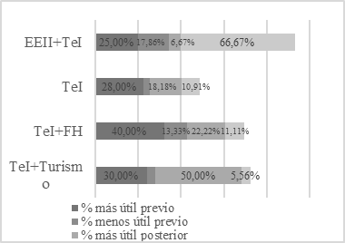
Source: Own elaboration

Indeed, this qualification is the only one that increases its consideration of usefulness in the subsequent survey for the language teaching methodology. Although the rest of the degrees continue to maintain a relevant opinion of usefulness in the subsequent survey, in all of them it decreases, in our opinion, either to opt for pragmatics, or to do so for discourse analysis. As in the previous case, EEII+TeI is the degree that finds the least useful of this subject in its training, which can be compared specifically with the fact that it is the one that most emphasizes pragmatics (see Graph 6). Thus, it can be seen that EEII+TeI and TeI+Turismo have the opposite opinion regarding the usefulness of the subjects of pragmatics and language teaching methodology. In fact, even its assessments are opposite: EEII+TeI values with the methodology of language teaching and pragmatics with a 3 and a 3.93 respectively, while TeI+Turismo does it with a 3.72 and a 3.28.
In all degrees, the assessment of discourse analysis decreases (see Graph 9),with EEII+TeI and TeI registering the most striking difference. The most relevant fact is that TeI+FH never votes in favor of this subject among the most useful in the subsequent survey (nor does it appear among the least useful). This contrasts if we compare with the assessment of Graph 9,since it is the degree that best values the subject (3.67), with the same score as for pragmatics (see figure 5above). TeI+FH is one of the most balanced degrees in subsequent surveys and that most differs from the rest of the degrees. In the subsequent survey, it shows 22.22% of opinions on greater usefulness for pragmatics, language teaching methodology and morphology, as well as 33.33% for syntax, the latter being the one that supposes the greatest contrast, given that it is one of the worst valued in general (even also for TeI+ FH, which also positions it as less useful in the subsequent survey with 22.22% of the opinions; see below Figure 18).
It is also striking that although EEII+TeI is the one that most decreases its valuation over time, it is the one with the highest percentage of opinion: both of matter with greater utility and of less utility. TeI follows a similar scheme, although not so manifest. Finally, TeI+Turismo always values discourse analysis as the most useful subject, which clashes with the assessment and percentage of pragmatics (see figure 5 and Graph 6above).
Figure 11. Assessment of lexicology and semantics according to degrees.
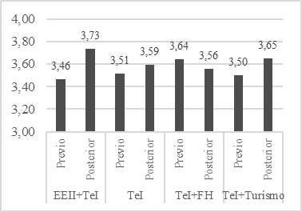
Source: Own elaboration.

Figure 12. Comparison of usefulness of lexicology and semantics according to degrees and periods.
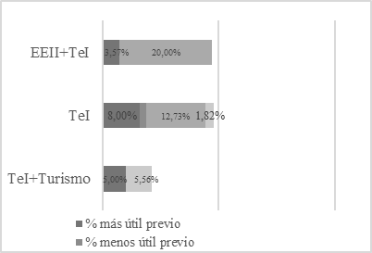
Source: Own elaboration.

Regarding lexicology and semantics, TeI+FH never considers this matter within its more or less useful options. For its part, TeI values it very positively (in fact, it is the third option voted, with 12.73%, after pragmatics and language teaching methodology), as well as EEII+TeI, also as the third option (20%), after pragmatics and discourse analysis. On the other hand, the percentages of non-utility are practically restricted to 5.56% of TeI + Tourism, a degree in which it goes directly from being an option among the most useful to being one among the least useful.
Next, we break down the data of the subjects considered least useful by the respondents.
Figure 13. Assessment of psycholinguistics according to degrees.
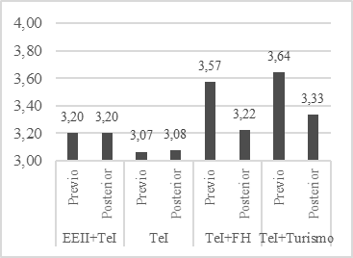
Source: Own elaboration.

Figure 14. Comparison of the usefulness of psycholinguistics according to degrees and periods.
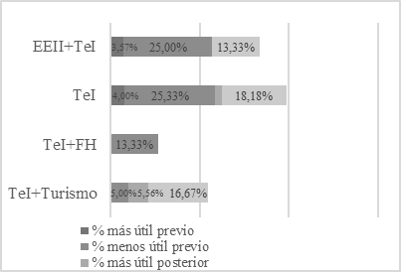
Source: Own elaboration.

In relation to psycholinguistics, EEII+TeI and TeI follow the same scheme: they do not change their assessment between surveys (they are also the smallest) but they do decrease the percentage of consideration as less useful subject. The only degree that considerably decreases its valuation (to 3.33) and also triples the opinion of little utility is that of TeI+Turismo.
On the other hand, TeI+FH never takes a position on the lack of usefulness of psycholinguistics in the subsequent survey, mainly because almost half of this promotion considers that the least useful subject is new technologies (see Figure 16below).

Figure 15. Assessment of new technologies according to degrees.
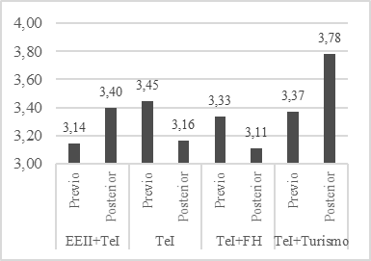
Source: Own elaboration.

Figure 16. Comparison of the usefulness of new technologies according to degrees andperiods.
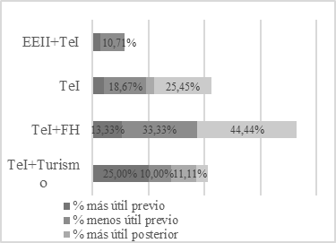
Source: Own elaboration.

In this case, the new technologies show a diversity of assessments over time, all of them with notable differences (see Graph 15),which marries with the disparity of socio-professional motivations of each degree. The lack of usefulness of new technologies is largely reserved for TeI and TeI+FH (see Figure 16). So much so that the case of TeI+Turismo stands out again, being the degree that best values new technologies and the only one that shows a remarkable value in the subsequent utility, since only this degree exceeds 10%.
Figure 17. Assessment of the syntax according to degrees.
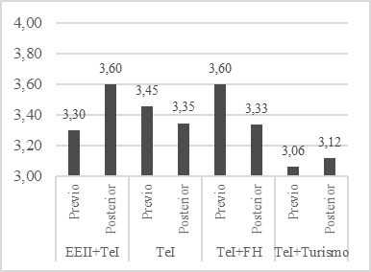
Source: Own elaboration.

Figure 18. Comparison of syntax utility according to degrees and periods.
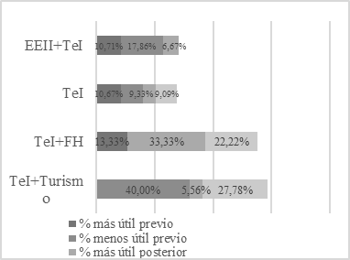
Source: Own elaboration.

In relation to syntax, EEII+TeI and TeI+FH show opposite assessments, which are also reflected in the subsequent usefulness: the first degree does not consider it a less useful subject and the second does (although it also stands out as useful; when talking about discourse analysis we already value the TeI+FH profile). The case of TeI+Turismo is again remarkable, given the reduced valuation in syntax and the pattern of usefulness that is identified, being the degree whose opinion remains high in the consideration of unhelpful subject (in fact, it is the subject that they most often consider less useful of their training, with 27.78%, followed by psycholinguistics, with 16.67%).
Regarding EEII+TeI, which does not stand out in an outstanding way in its opinions of less useful subjects in any of the previous graphs, it should be remembered that in Graph 8 this degree shows 66.67% of opinions about the methodology of teaching languages is the least useful subject in their training.

Conclusions
The analysis carried out has made it possible to relate data such as general valuation changes and between degrees, as well as considerations of greater or lesser usefulness over time. Therefore, it is possible to outline the following conclusions:
- In relation to the most relevant and useful subjects, the pragmatic one stands out especially, not only for being the most voted, but for being the one that boasts an increase in the valuation of the most outstanding utility from one period to another. It is followed by language teaching methodology and discourse analysis. The subjects best valued by the majority of respondents are lexicology and semantics (3.56), pragmatics (3.45), language teaching methodology (3.35) and terminology and lexicography (3.38). The generalization in the consideration of usefulness of these subjects justifies the need to propose a significant learning in these specific subjects and to consult through interviews or longer questionnaires on the reasons that lead the students to such consideration.
- As for the subjects considered less useful, it is worth mentioning new technologies (19.59%; 3.28%), psycholinguistics (15.46%; 3.12) and syntax (12.37%, 3.27). An important fact about these three subjects is that they do not see their percentage of usefulness between periods altered considerably, so it is reflected that there has been no change of opinion of the students about the lack of usefulness of these subjects in their training. This fact has relevant didactic implications, since it implies that it is necessary to identify which elements provoke these evaluations and the consideration as unhelpful subjects.

Regarding the differences and similarities between degrees, the following can be seen:
- When assessing pragmatics, it can be said that all degrees show a similar assessment in the two surveys, with the exception of EE+TeI, which increases significantly. In addition, it is the subject that has the highest percentage of opinions on its usefulness computed in the subsequent survey, with the exception of TeI+Turismo, which is the degree that is most distant from the other three. Indeed, it has been possible to identify that the degrees of EEII+TeI and TeI+Turismo have a contrary opinion regarding the usefulness of the subjects of pragmatics and language teaching methodology. In fact, it has been possible to identify that TeI+Turismo is the degree that most often opposes or differentiates itself from the rest. Despite this, it has also been identified that TeI+FH is one of the most balanced degrees in subsequent surveys and one of the most different from the rest of the degrees specifically in this distribution of utility, given that the rest of the degrees do show more polarized opinions, where the most useful and least useful subjects have a much more irregular and dispersed representation than in TeI+FH.
- If we stop to assess the conclusions we reach about TheI+ Tourism, different aspects can be highlighted, since it is the one that best values the subjects that are considered, in general, less useful: (a) when assessing the subject of lexicology and semantics, this degree is the most polarized, going from valuing it exclusively as one of the most useful to treating it as one of the least useful; (b) with respect to psycholinguistics, it is the only qualification that triples the opinion of little use; and (c) with respect to new technologies, it is undoubtedly the one that most values this matter, as well as the only one that shows an important value by being included as one of the most useful in the subsequent survey. These differences, which sometimes oppose the assessments of the rest of the respondents, could be related to the competence profile of this degree, the only one coordinated by another faculty, that of Labor Sciences, and not by the Faculty of Philosophy and Letters. These differences could also be explained by the fact that these students take many other non-linguistic or philological subjects, such as statistics, accounting or international law, which could affect the assessments and opinions on usefulness they give in the survey.

Among the pedagogical implications of these results is the need to rethink certain topics, such as psycholinguistics, syntax or new technologies; especially the latter, given the relevance not only in today's world, but also in the professional and academic practice of translation. In fact, the main reflection that should be made around this subject is related to the causes that cause them not to be considered useful or, specifically, from the perspective of the student, why students should consider them useful and why it is not possible to consider them at the same level as the rest of the subjects with more votes.
We venture to propose that the main differences in the opinion of usefulness and the evaluations of the subjects attend to the socio-professional and academicmotivations, shown by each of the students enrolled in the different degrees, although this statement should be based on a future study in which the causes outlined by the students to determine these evaluations and utilities are taken into account. In fact, this suspicion that the socio-professional motivations recorded in the survey (and not the personal motivations) would justify this usefulness, would make us rethink whether it is possible to meet such disparate competency and professional needs in the same and single subject for four such different degrees, which would have an impact on the programming of the degree and the subjects taught by the areas of knowledge.
During the discussion of the data, it has been possible to glimpse certain problems, which involve some limitations of the work, mainly linked to the fact that Linguistics is a subject in which it is not possible to deepen in all subjects, so it is chosen to achieve the proposed competences through a panoramic approach of the contents and subjects that make up the scientific field of linguistics. The first could be related to the lack of rigorous knowledge about the subjects by the students in the previous surveys, which could imply that the students vote with partial knowledge. This is related to the blurred boundaries between disciplines, such as those observed between pragmatics and discourse analysis, for example.
Therefore, some future lines of work are proposed to shed light on these limits of the study or to try to describe, in the first instance, and explain, in the second, the results. It would therefore be necessary:
- Identify the justifications or causes that lead students to assess the subjects in this way or to consider their usefulness in this measure.
- Compare the results with the evaluations of the last year of the Degree in Translation and Interpreting, in which, thanks to the Final Degree Project, they can rethink the usefulness or evaluations of certain subjects.
- Compare the results with the assessments of other degrees where the subject is also taught at the University of Córdoba.
- Compare the results with the evaluations of students from other Spanish universities.

References
Abellán, C.M. A. (2017). Attitudes towards gender equality in a sample of students from Murcia. Revista Complutense de Educación, 28(1), 45-60. doi: http://dx.doi.org/10.5209/rev_RCED.2017.v28.n1.48715
Allport, G. (1935). Attitudes. In C. Murchison (Ed.), Handbook of Social Psychology (p. 798-844). Worcester: Clark University Press.
Arnold, J. (2019). Autonomy and motivation. In J. Muñoz-Basols; E. Gironzetti & M. Lacorte (Eds.). The Routledge Handbook of Spanish Language Teaching: methodologies, contexts and resources for teaching Spanish L2 (pp. 26-37). London: Routledge. doi: http://dx.doi.org/10.4324/9781315646169-3.
Attardo, S. & Brown, S. (2005). What's the use of linguistics? Pre-service English teachers' beliefs towards language use and variation. Applied Linguistics and Language Teacher Education, 4,91-102. http://dx.doi.org/10.1007/1-4020-2954-3_6.
Auzmendi, E. (1992). Attitudes towards statistical mathematics in secondary and universityeducation. Bilbao: Messenger.
Briñol, P., Falces, C. & Becerra, A. (2007). Attitudes. In F. Morales; E. Gaviria; M.C. Moya & M. I. Cuadrado (Eds.), Social Psychology (p. 457-490). Madrid: McGraw-Hill.
Comas, C., Martins, J. A., Nascimento, M.M. & Estrada, A. (2017). Study of Attitudes towards Statistics in Psychology Students. Bolema: Boletim de Educação Matemática, 31(57), 479-496. doi: http://dx.doi.org/10.1590/1980-4415v31n57a23.
Estrada, A. (2007). Attitudes towards Statistics: a study with teachers of Primary Education in training and in practice. In M. Camacho; P. Flores & M. P. Bolea (Eds.), Research in Mathematics Education XI (p. 121-140). La Laguna: SEIEM.
Foss, D. H. & Kleinsasser, R.C. (1996). Preservice elementary teachers' views of pedagogical and mathematical content knowledge. Teaching and teacher Education, 12(4), 429-442. doi: http://dx.doi.org/10.1016/0742-051X(95)00049-P.
Fuentes, L., Errázuriz, M.C., Davison, O. A. & Cocio, A. (2019). Validation of a survey of reading attitudes in students of basic education. Literature and linguistics, (39) 225-250. doi: http://dx.doi.org/10.29344/0717621X.39.2012.
Gómez-Chacón, I.M. (2016). Empirical methods for the determination of structures of cognition and affect inmathematics. In J. A. Macías et al. (Eds.), Research in Mathematics Education XX (p. 93-114). Malaga: Spanish Society for Research in Mathematics Education.
Hanna, S. F. (2009). Exploring MA students' attitudes to translation theory and practice. The sign language translator and interpreter, 3(2), 141-155.
Heinemann, P. (1980). Pedagogy of non-verbalcommunication. Barcelona: Herder
López, W. O. F. & Auzmendi-Escribano, E. (2018). Attitudes towards mathematics in university education and its relationship with the variables gender and ethnicity. Profesorado, Revista de Curriculum y Formación del Profesorado, 22(3), 231-251.
Marbá-Tallada, A. & Márquez, C. (2010). What do students think of science classes? A cross-sectional study from sixth grade to fourth grade of ESO. Science Teaching, 28(1), 19-30.
Marquès, P. (2001). Didactics. The processes of teaching and learning. Motivation. Barcelona: Department of Applied Pedagogy, Faculty of Education, UAB.
Meneses-Benítez, G. (2007). University: NTIC, interaction and learning. Edutec. Electronic Journal of Educational Technology, (29), 49-58. Doi: http://dx.doi.org/10.21556/edutec.2006.20.518.
Minera-Reyna, L. E. (2010). The motivation and learning attitudes of E/LE in non-Hispanist students at LMU University Munich. Nebrija Journal of Linguistics Applied to Language Teaching, (8), 42-80.
Moreno, A. E., Rodríguez, J. V. R. & Rodríguez, I. R. (2018). The importance of emotion in learning: proposals to improve student motivation. Cuaderno de pedagogía universitaria, 15(29), 3-11.
Pinilla-Herrera, A. & Cohen, A. (2019). Learning styles and strategies. In J. Muñoz-Basols; E. Gironzetti & M. Lacorte (Eds.), The Routledge Handbook of Spanish Language Teaching: methodologies, contexts and resources for teaching Spanish L2 (p. 38-51). London: Routledge. doi: http://dx.doi.org/10.4324/9781315646169-4.
Pinto, M., Gálvez, C. & Dijk, T. V. (2018). Documentary content analysis: information processing. Madrid: Synthesis.
Ramos, R. T. & Gómez, N. N. (2019). The influence of the teacher on motivation, learning strategies, critical thinking of students and academic performance in the area of Physical Education. Psychology, Society, & Education, 11(1),137-150.
Sabra, Y. (2018). The Importance of Linguistic Knowledge to Translators-to-be: The Lebanese Higher Education Context. International Journal of Social Sciences & Education, 8(4),109-118.
Smith, M. (2019). Students' emotions and their impact on learning: Emotionally positive classrooms. Madrid: Narcea Ediciones.
Traver-Martí, J. A. & Ferrández-Berrueco, R. (2016). Construction and validation of a questionnaire of attitudes towards educational innovation in theuniversity. Educational Profiles, 38(151), 86-103. doi: http://dx.doi.org/10.22201/iisue.24486167e.2016.151.54917.
Van Aalderen-Smeets, S. & van der Molen, J.W. (2013). Measuring primary teachers' attitudes toward teaching science: Development of the Dimensions of Attitude toward Science (DAS) Instrument. International Journal of Science Education, 35(4), 577-600. doi: http://dx.doi.org/10.1080/09500693.2012.755576.
Zampieron, A., Corso, M. & Frigo, A.C. (2010). Undergraduate nursing students' attitudes towards organ donation: a survey in an Italian university. International nursing review, 57(3), 370-376. doi: http://dx.doi.org/10.1111/j.1466-7657.2010.00806.x.

In addition to the values recorded in the Table 2, the student could mark the value "does not know/does not answer", exposed in results with the acronym NSNC.

